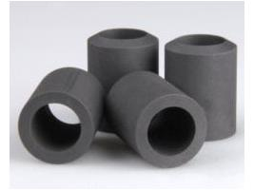
PRODUCT CATALOUGE & DATA SHEET
NISARG SHUKLA
JAY POLY TECH INDUSTRIES

SINTERED POROUS CARBON FILTER ELEMENT

As experts in carbon materials, we are pleased to offer sintered porous carbon filter element to our customers in industries such as brine filtration application, semiconductor and industrial heating.
Our sintered porous carbon materials exhibit great properties such as particle size, porosity and overall permeability and features great benefits such as :-

- High strength
- High insulation value
- Good stability in highly corrosive environments
- Uniform porosity for diffusion
- Flow control

The sintered porous filter elements are manufactured from a porous, ceramically bonded carbon media that has a high mechanical strength. This sintered filter material is distinguished by its excellent thermal resistance as well as thermal shock resistance. For this reason the filter elements are well suited for the filtration of hot fluids with fast temperature changes. The high performing sintered porous filter elements are mainly used for high temperature applications.
Our engineers work closely with our customers to select the right material based on porosity
for flow, material density, size, and strength. To see how we can work with you to select the right material for your product, contact us today.

- Design & Operating Conditions (Temperature, Pressure, and Flow Rate)
- Removal Rating and Efficiency
- Required Clean Pressure Drop
- Required Alloy (Chemical and Temperature Compatibility)
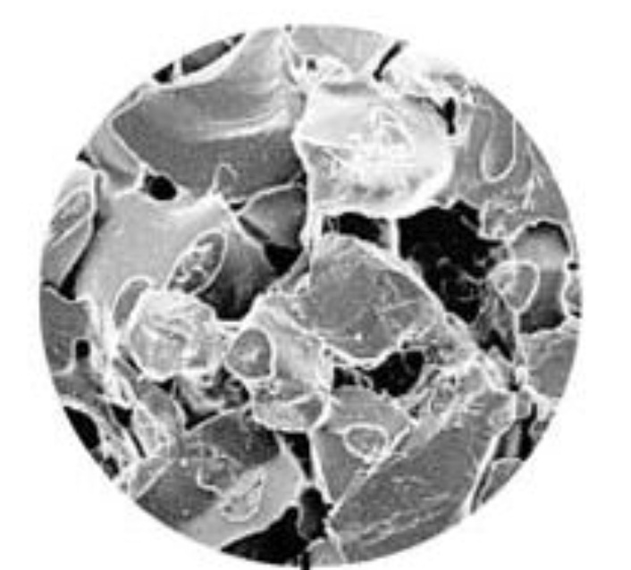
- Required Media Strength (i.e., Ultimate Tensile Strength, Fatigue Strength, or Modulus of Elasticity)

APPLICATIONS

- Particle filtration of liquids
- Polish filtration of agressive liquids
- Catalytic recovery from reaction solutions
- Caustic soda
- Particle separation from condensate
- Particle filtration of gases
- Particle separation from water vapour
- Particle separation from aggressive exhaust gasesScanning Electron Micrograph Support body for precoat filtration
- Polish filtration of cell brine in chlor-alkali-electrolysis according to the membrane or
diaphragm process

TECHNICAL INFORMATION

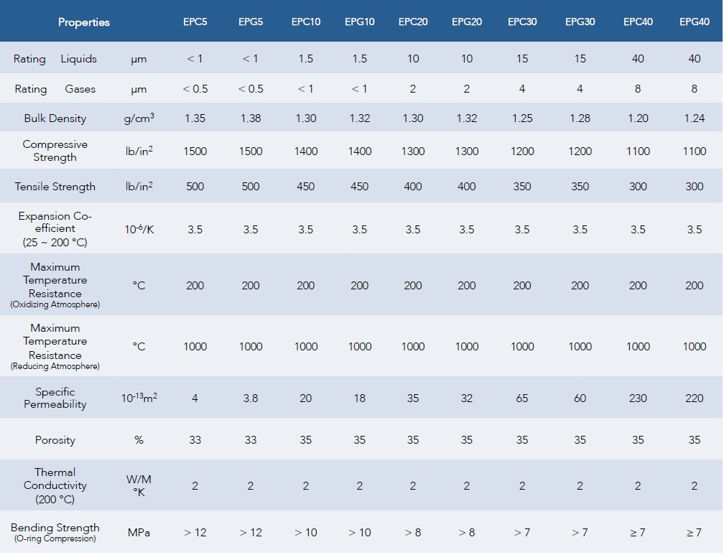

GENERAL INFORMATION

- Sintered Porous carbon filter elements are to be handled with care.
- Careful consideration should be paid to operating temperature and chemical resistance.
- The filter elements are usually installed in the filter housing using a metal tie-rod system, flat
gaskets and a temperature compensation plate.

CHEMICAL RESISTANCE

Sintered porous filter elements are resistant against hot and cold acids and alkaline solutions
in the range from pH 0 to pH 14. They have limited resistance against strongly oxidizing
liquids. Water vapour can be filtered using this elements and back-washing of the filter media
is possible. Sintered porous carbon filter elements show excellent
resistance against salt solutions.

DIMENSION INFORMATION (MM)

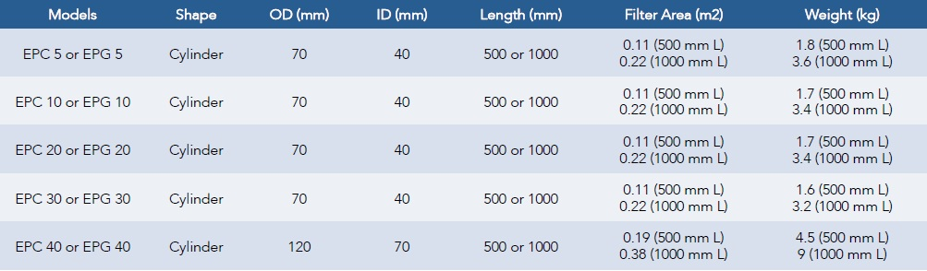
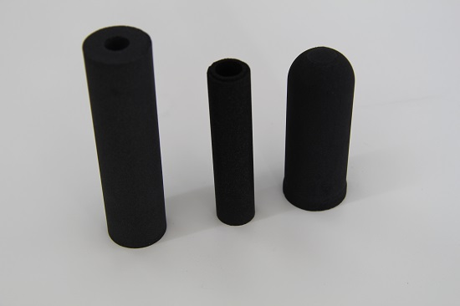

STANDARD DIMENSION

- 60 OD X 40 ID
- 70 OD X 40 ID
- 120 OD X 70 ID

- Length are availble in 250, 500, 750, 1000, 1500, 2000 mm

